
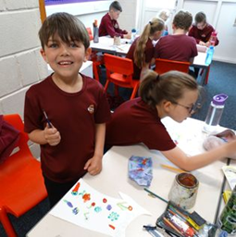
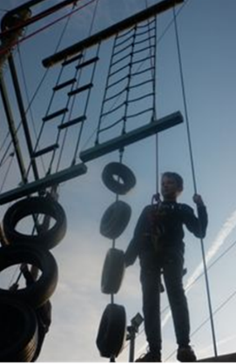
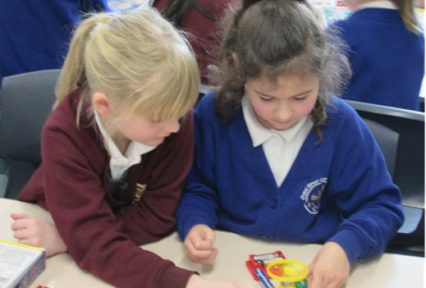

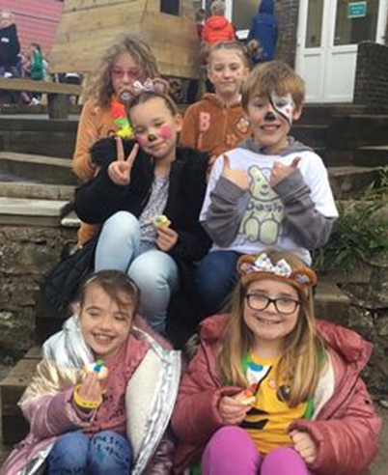
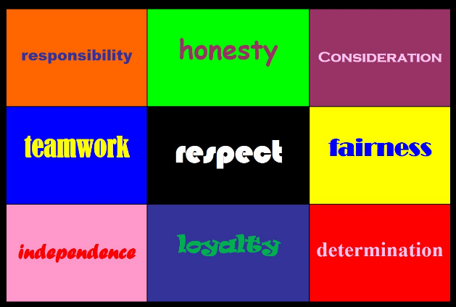
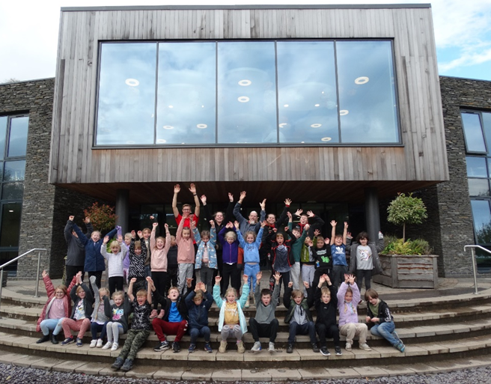
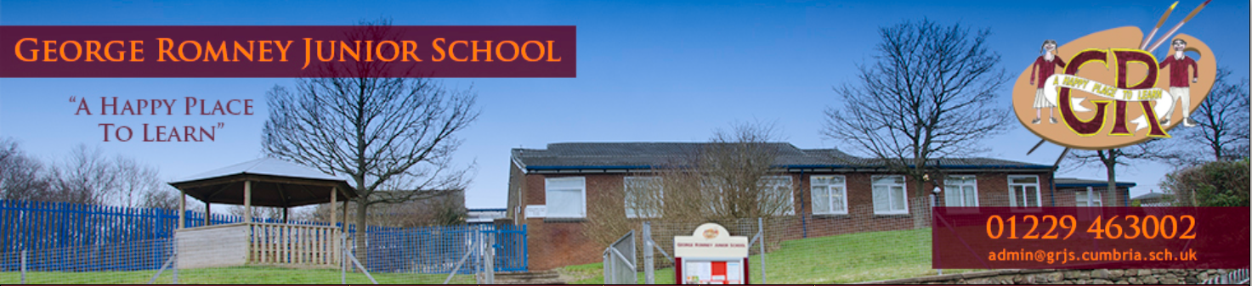
George Romney Junior School: Prospectus

George Romney Junior School: Welcome
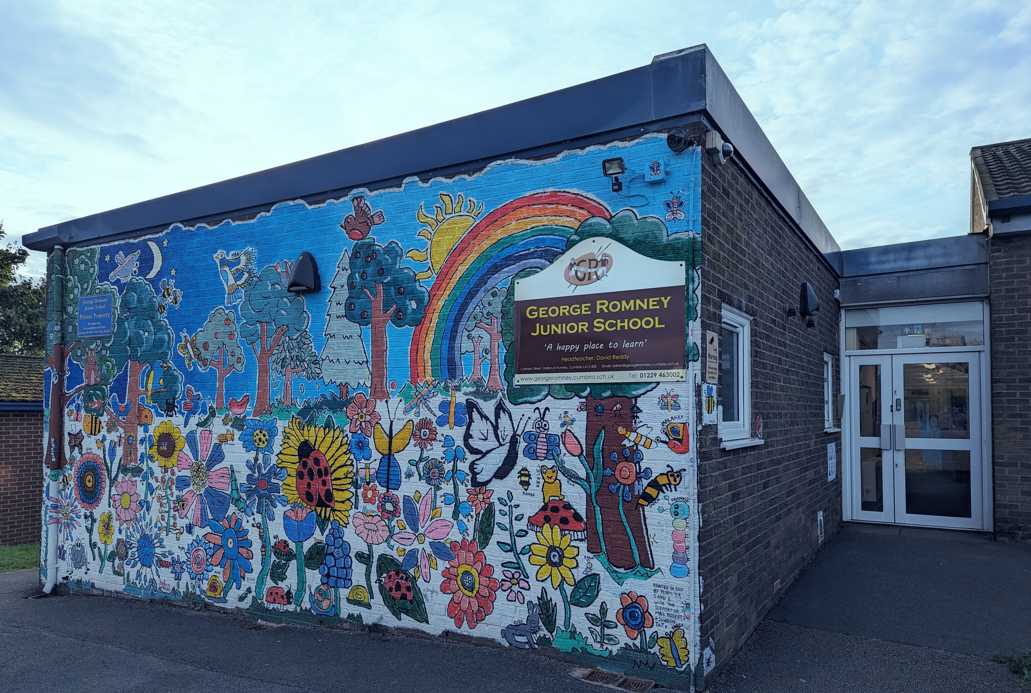
We are delighted to welcome you to our school! George Romney Junior School is a community junior school that was officially opened in 1981 and has been serving the children and families of Dalton ever since.
I have the privilege and pleasure of being the Executive Headteacher here since January 2026. Our staff team continue to grow and develop our curriculum in a unique and special way which we think really inspires and engages our children. Over the years we have built many relationships with other schools, organisations and businesses - all of which for the benefit of our children and their families.
We are currently organised into upper junior and lower junior phases; with mixed age classes in each phase. The school was originally designed to be 'open plan' but now consists of classrooms, additional learning spaces, an ICT suite, a dedicated art space, main hall, newly refurbished library and "The Den" where our after-school provision is based.
We are fortunate enough to have a site with some excellent facilities: plenty of playground space, a wildlife outdoor learning area, sports fields, two wooden gazebo shelters, an all-weather outdoor active playground and outdoor gym.
Named after the famous portrait artist who was born in Dalton; over the years, the school has built a reputation for high standards across the curriculum and developed particular strengths in art and sports. As a school, our attitude to learning and our inclusive approach to our community is probably best explained in our vision statement...

George Romney is a safe and happy place to learn. Our children are nurtured as individuals with different abilities and talents which are celebrated and developed. Our stimulating and reflective curriculum inspires children to ask questions and develop positive attitudes to learning, both now and for the future.

At George Romney we understand the importance of belonging and contributing to our local, national and global community. We encourage our children to grow into responsible citizens and learn the skills and values required for life in the 21st century.

Our 'Core Values' which were carefully chosen by staff, parents and governors are celebrated each week here in school and are understood by all children to being the key to our school being "A happy place to learn"!
I look forward to meeting you...
Scott Macmillan

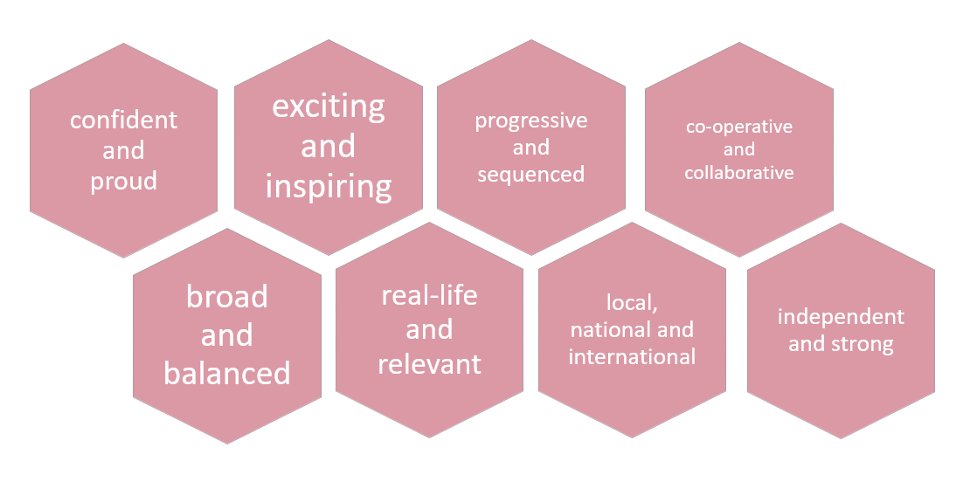
Our children live in an ever-changing, rapidly advancing world where new knowledge and new skills need to be acquired, understood and mastered at a rate previously unheard of. We aim to enable children to learn the full range of knowledge, skills and understanding in order to appreciate their world as well as recognising and embracing their role in becoming citizens who make a positive contribution to our society; now and in the future. Our community and its environment help shape the way in which we structure learning opportunities. We balance the celebration of all positive aspects of our local context with the ability to look beyond the Furness Peninsula in order to understand and embrace the wider world. We are totally committed to learning of the highest standard in academic, personal and social forms and have these aspirations for all children in our care.
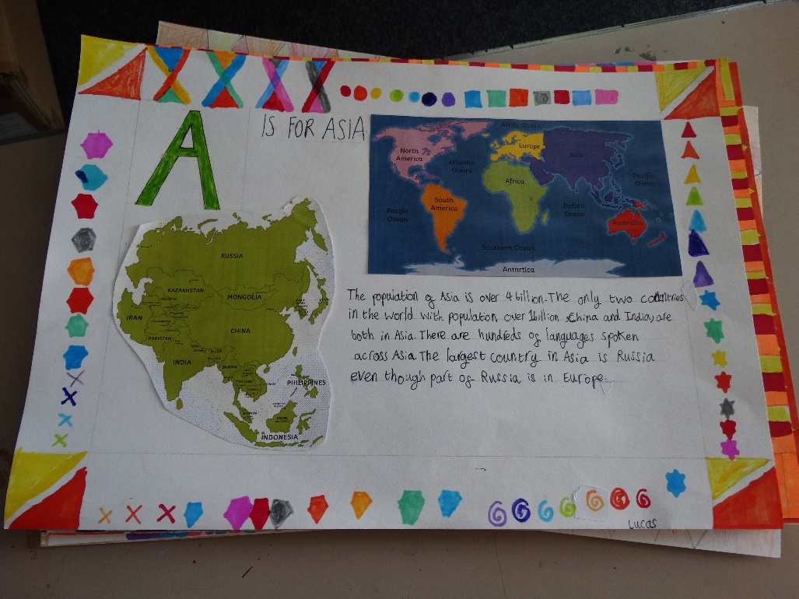
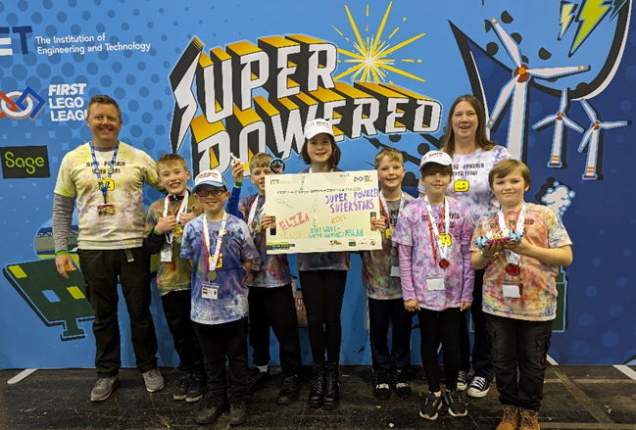

George Romney Junior School: Curriculum
George Romney Junior School: Working together
All staff are fully committed to working together with all children, all parents and all governors as partners to make our school the best place for our children that it can be.
All staff know and understand their statutory duty in terms of safeguarding all children and families; this responsibility covers all areas of school life.

During the course of the school year, we build in lots of opportunities for parents and families to be actively involved in their child’s learning. As well as meetings and newsletters; we have termly curriculum updates as well as questionnaires; parent & child home tasks; focused curriculum exhibitions and other informal opportunities to be in school and be involved.

We have excellent relationships with colleagues in Chapel Street Infant School as well as colleagues in Dowdales. Staff work conscientiously to make sure that transition to and from George Romney is a positive and supportive process. We are particularly good at celebrating the things that we do in partnership with these other Dalton schools (see our ‘Statement of Intent’ on our school website).

We are a key partner in the Furness Primary Collaborative (a group of schools who have been working together for almost 10 years now). We also share and explore ideas about curriculum and learning with other partners in our local area and nationally…

Teamwork, collaboration and learning to learn together are essential skills that we encourage all children to try. We know from talking to parents that this is something they really value about the way we work here at school – after all it is how the children will need to learn as they enter their chosen world of work…

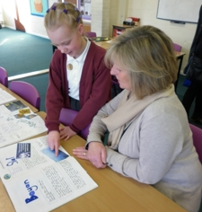

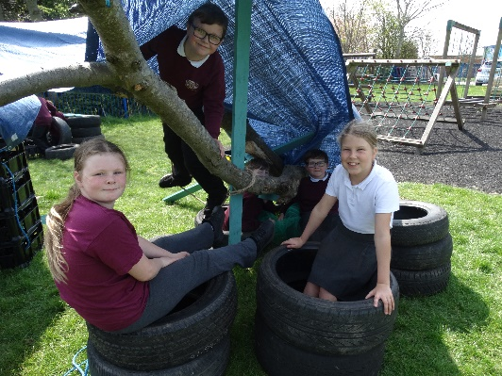

 | 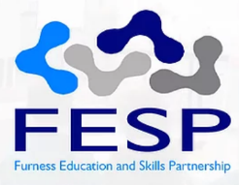 |  |  |  |  |  | 

Arbour
At George Romney Junior School we use Arbour – a cloud-based school management system which includes online payment and communication tools and even a parent specific app which can be used on your smartphone, tablet or computer. Upon your child starting at George Romney Junior School, we will automatically send out a registration link for this system.
If have any questions regarding Arbour please contact Mrs Gallagher in the school office and she will be able to help.

Extra-Curricular Clubs
We offer a wide range of after school clubs organised by staff, parents and external coaches. Details of these are sent out each term.

Breakfast and Afterschool Clubs
We operate a daily breakfast and after school club. Breakfast Club starts from 7.45am each day at a cost of £3.50 per child (breakfast included).
After school club starts daily from 3.20pm. Children can be collected from after school club at either 4.30pm or 5.30pm Monday to Thursday and up to 5pm on a Friday. The cost until 4.30pm is £4.50, 5.30pm is £9 and 5pm on a Friday is £8 (snacks included).

Swimming
Swimming lessons will take place from after October half-term until the end of May. Further details of contributions etc. will be circulated nearer the time.

Lunch-time Arrangements
All children will be required to bring a packed lunch.
A ‘Wonde’ food voucher redeemable in the local supermarkets will be provided for those children eligible for free school meals. If your child is entitled to free school meals, please make sure you indicate this on your Data Capture form. If you are unsure if you are entitled to free school meals then please ask Mrs Gallagher in our school office or visit:

Free school meals and clothing vouchers | Westmorland and Furness Council

Leave of Absence
Parents are asked to avoid taking children out of school during term time. School is required to ensure full attendance for all children. In accordance with Westmoreland and Furness Council’s policy, leave of absence for holidays during term time should not be authorised by the school; however, leave of absence may be granted in exceptional circumstances.
Leave of absence application forms are available from the school office.

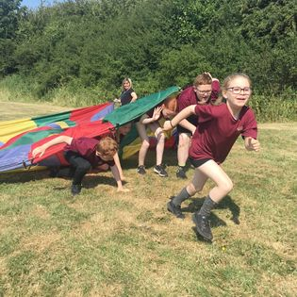

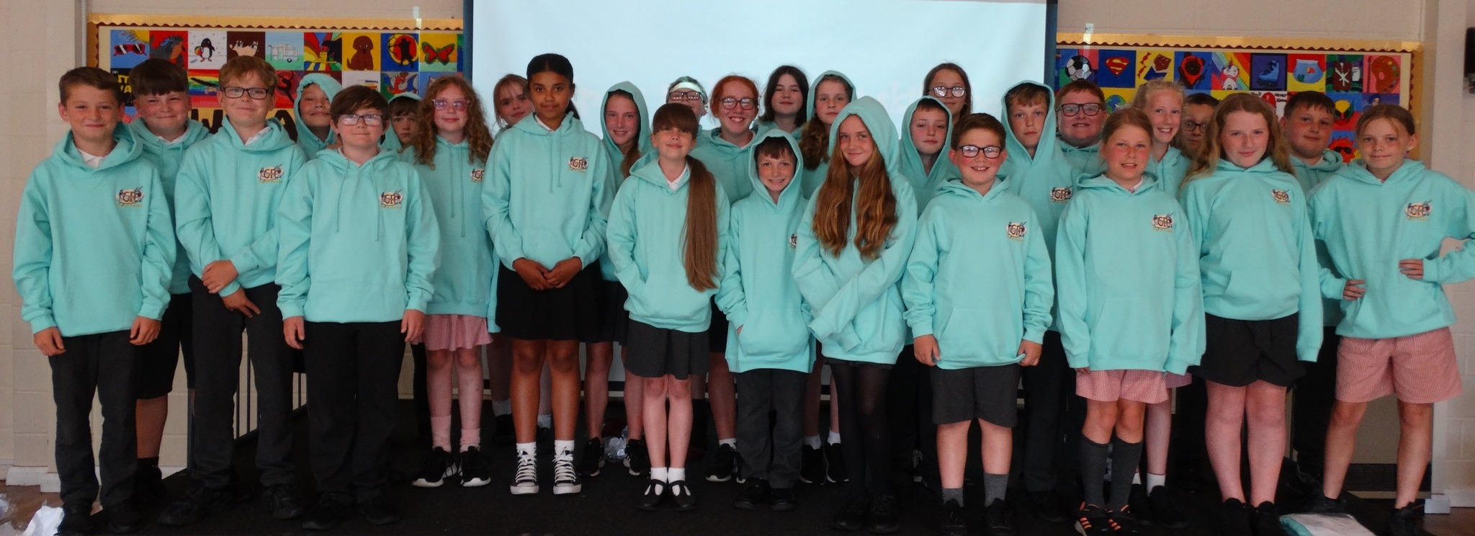

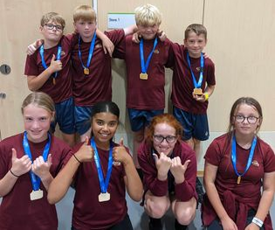

George Romney Junior School: Getting Organised!
George Romney Junior School: Uniform
Uniform
We believe in the smart appearance of our pupils. All the children wear our school colours. This helps them develop a pride in their appearance and a sense of belonging to the school.

We would like all children to adhere to the following items of uniform:
Burgundy sweatshirt or cardigan. (Only sweatshirt or cardigan to have the school logo on.)
White polo-shirt
Grey skirt, pinafore dress or trousers,
Black shoes (or trainers – if they are all black),
Burgundy ‘George Romney’ Fleece (optional)

Summer uniform (optional) is red, checked gingham-style dress or grey shorts.

PE kit is a maroon, dri-fit Joma t-shirt and black shorts with trainers. Maroon Joma track top and plain black jogging bottoms/leggings.
On PE days all children should come to school wearing their PE Kits.
The children will need a swimming costume or trunks, towel and hair brush for school swimming lessons. Please note Dalton Leisure Centre do not allow long Bermuda shorts.

OPAL
(Outdoor Play and Learning) – To enable all children to enjoy all play options at lunchtimes we would like wellingtons and waterproof trousers for the Autumn and Spring Terms.

'Pre-loved’ uniforms
Second-hand uniforms can be of benefit to all parents, by extending the life of garments, it is more sustainable. Any parents wishing to donate good quality items or those wanting to purchase these from school should contact the school office via email.

All items are widely available at supermarkets (to be purchased and embroidered with the school’s logo if preferred).
The main provider of our school uniform is Identity in Barrow: https://www.oneidentity.co.uk

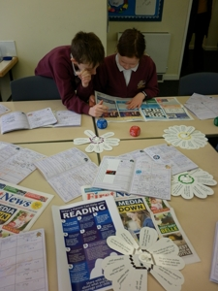

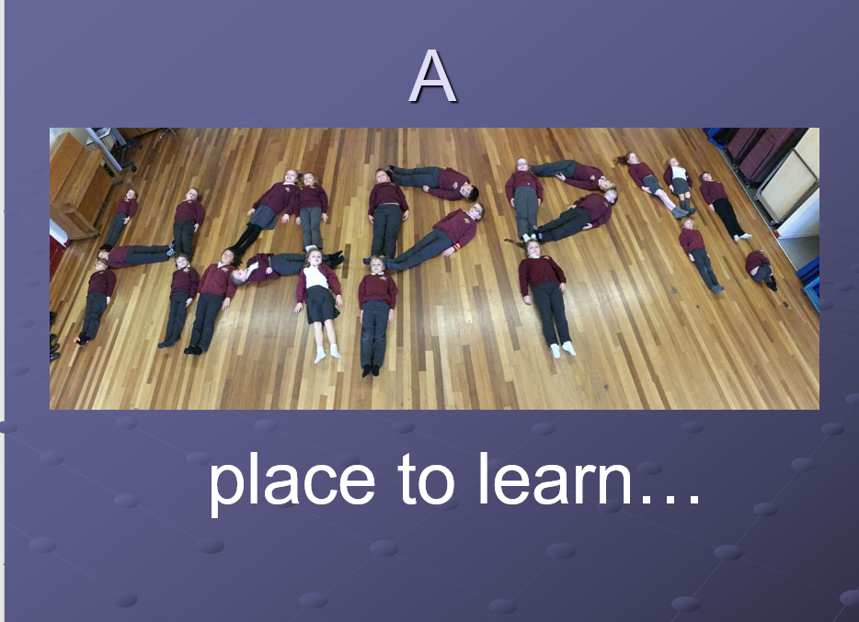
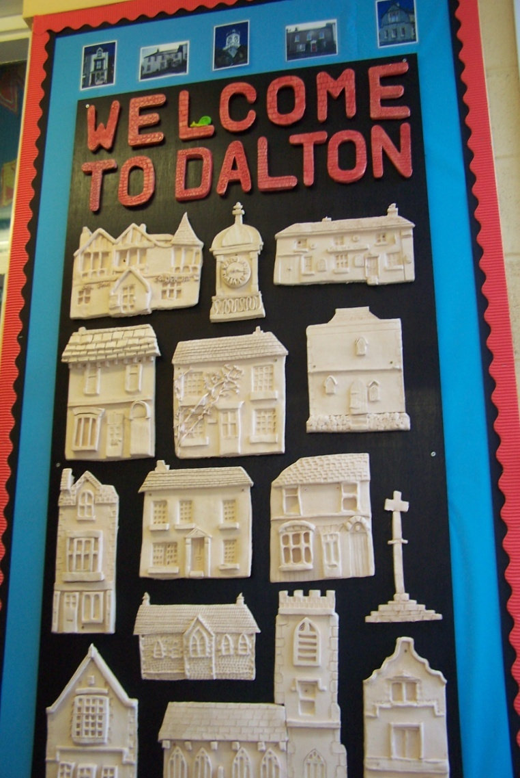
Attendance and Punctuality
Every member of staff wants the best for your child. We all believe coming to school every day, on time and ready to learn is the best way you can help your child as a parent. We talk regularly about the importance of excellent attendance and the importance of not missing learning – after all, we are ‘A happy place to learn!’

We ask that children do not arrive before 8:40am for their own safety; all children arrive via the lower gates and wait on the playground where a member of staff will be on duty. The school bell rings at 8:50am, ready for registration and a prompt start to their learning! If your child is unable to attend school, please telephone the office before 9:30am or leave a message on the answer phone.
(School Office hours are from 8:00am until 4:00pm).

Leave of Absence
Parents are asked to avoid taking children out of school during term time. School is required to ensure full attendance for all children. In accordance with Westmoreland and Furness Council’s policy, leave of absence for holidays during term time should not be authorised by the school; however, leave of absence may be granted in exceptional circumstances.
Leave of absence application forms are available from the school office.

Address: Cobden Street,
Dalton-in-Furness,
Cumbria LA15 8SE.

Telephone: 01229 463002
Email admin@grjs.cumbria.sch.uk
Website: www.gjrs.cumbria.sch.uk

Type and age range: Community Junior School 7–11 years (Y3 – Y6)

Admission no: 45 per year group

Local Education Authority: Westmorland and Furness
Addresses: Barrow Town Hall, Duke Street, Barrow in Furness, Cumbria LA14 2LD
Website: www.westmorlandandfurness.gov.uk
www.westmorlandandfurness.gov.uk

George Romney Junior School: and finally…

