George Romney Junior School: Strategic Priorities 2025-2026:

- A continued focus on supporting and developing good mental health and well-being and the obvious links to good physical health and activity. To actively explore all possibilities to enable all children (regardless of their potential barriers) to fully engage in all aspects of learning and school life.
- To improve progress and standards in children’s writing in English and across the curriculum. This will be done through consideration of local and national priorities raised by the DfE ‘Writing Framework’ and FPF project work. It will build on previous progress made through engagement using dialogue and oracy.
- To review and refine our curriculum and enhance it with both deeper learning opportunities and regular opportunities of checking skills and knowledge are embedded into the children’s learning journey.

At George Romney Junior School, we want the children to know:

- We are all going to keep looking after our bodies and our minds by keeping fit, eating a balanced diet and talking about how we feel to our friends, families and trusted adults. Some of us might need more help with this and that is fine!
- We want to keep on learning how to be confident, how to talk about our learning using the correct words, how to read and find more about our learning and use our writing skills to record our learning in different ways
- We want all children to want to make good progress in their learning. We want our children to understand how they are making progress in all areas of the curriculum and how the things they learn, link together and follow on

 | 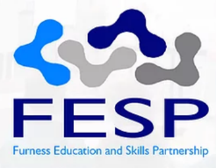 | 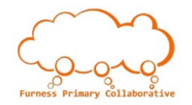 | 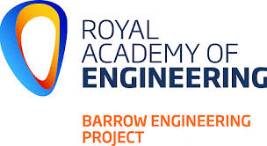 |  |  | 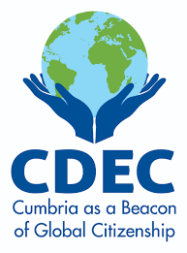 | 

